P425/2
APPLIED MATHEMATICS
Paper 2
July/Aug. 2019
3 hrs.

INTERNAL MOCK EXAMINATIONS – 2019
UGANDA CERTIFICATE OF EDUCATION
APPLIED MATHEMATICS
Paper 2
3 hours

INSTRUCTIONS TO CANDIDATES:
Attempt all the eight questions in section A and any five questions from section B.
Any additional question (s) answered will not be marked.
Silent non – programmable electronic scientific calculators may be used.
Mathematical tables with a list of formulae and squared papers are to be provided.
All necessary calculations must be shown clearly on the answer sheet provided as the
rest of the answers, therefore no paper should be provided for rough work.

Begin each question on a fresh page of the sheet of the answer booklet.

Indicate the degree of accuracy at the end of each question attempted using Cal for
calculator or Tab for mathematical tables.

In numerical work, take acceleration due to gravity g to be = 9.8ms⁻².

Turn Over

SECTION A: (40 marks)
Answer all questions in this section.
1. Two events $A$ and $B$ are such that $P(A) = 0.4$, $P(B) = 0.7$ and
$P\left(B/A\right)=0.3$. Find the probability that neither $A$ nor $B$ occurs. (05 marks)

2. Taking $6$ ordinates evaluate $\int_{12}^{13}{\left(Sin x\right)\log{x dx}}$, using the trapezium rule to $3$decimal places. (05 marks)

3. To a woman in a car travelling at ${20kmh}^{-1}$ North East, the wind appears to blow from the West with speed ${16kmh}^{-1}$. Find the actual velocity of the wind. (05 marks)

4. The mass of a group of males are normally distributed with mean $80kg$and standard deviation $2.6kg$. Determine the probability that the mass of a male chosen at random is less than $78.5kg$. (05 marks)

5. A particle of weight $50N$ is placed on a smooth plane inclined at arc $sin\left(\frac{1}{2}\right)$ to the horizontal. Find the horizontal force $P$, required to keep the body in equilibrium and the normal reaction. (05 marks)

6. A random variable $Y$ has probability distribution $f(y)$ as

$$y$$ | $$1$$ | $$2$$ | $$3$$ | $$4$$ | $$5$$
$$P(Y=y)$$ | $$0.10$$ | $$p$$ | $$0.20$$ | $$q$$ | $$0.30$$

Given that $E(Y) = 3.5$;
Determine;
(i) the values of $p$ and $q$,
(ii) $P\left(X ≥2/X≤4\right)$. (05 marks)

7. Show that the equation $e^{x}=4\sin{x}$ has two roots between $x = 0$ and $x = 1.5$. Hence use linear interpolation once to determine the smaller root correct to $3$ decimal places. (05 marks)

8. An object of mass $5kg$ is initially at rest and is acted upon by a force
$F = 2i + 3j - 4k$. Find its velocity after 3 seconds. (05 marks)
$$\sim$$
$$\sim$$
$$\sim$$
$$\sim$$

SECTION B: (60 marks)
Answer any five questions from this section.
All questions carry equal marks.
9. (a) A particle is projected from a point $O$ with speed $u$ at an angle $θ$ to the
horizontal. Show that its height $y$ above $O$ when it has travelled a distance $x$horizontally is given by
$y=xtan θ-\frac{gx^{2}\sec^{2}θ}{{2u}^{2}}$. (04 marks)

(b) After $2$ seconds of projection, a particle projected from the top of a vertical cliff $6 m$ high with speed ${u ms}^{-1}$ at an angle of elevation $θ$ to the horizontal, passes just above the top of a vertical pole post which is $4m$ high and $8 m$ horizontally away from the base of the cliff.

(i) Show that $tan θ=2.2$. (05 marks)
(ii) Find the value of $u$. (03 marks)

10. Study the table below;
Mass (g) | $$20-24$$ | $$25-34$$ | $$35-38$$ | $$39-44$$ | $$45-49$$ | $$50-54$$
Frequency density | $$1.2$$ | $$1$$ | $$2$$ | $$1.5$$ | $$1$$ | $$0.4$$

(a) (i) Construct a histogram using the data.
(ii) Use the histogram to estimate the mode.
(b) Calculate the mean mass. (12 marks)

11. (a) Show that the Newton – Raphson method of finding the root of $tanx –4x = 0$ given by
$x_{n+1}=\frac{x_{n}\tan^{2}x_{n}- {tanx}_{n}+ x_{n}}{\tan^{2}x_{n}- 3}$ starting with $x_{o}=4.66$, show that
$x_{2}=4.6588$.

Turn Over

(b) The volume of a bowl of radius, $r$ and depth,$h$ is given by
$V=\frac{π}{3}h^{2}\left(3r-h\right)$.
Show that the relative error in the volume of a bowl is given by;
$\frac{ΔV}{V}= \frac{2 Δh}{h}+ \frac{3Δr + Δh}{3r-h}$. Hence evaluate $\frac{ΔV}{V}$ given that
$r = 3.21cm$ and $h = 5.5cm$.
(12 marks)

12. The probability density function of a random variable X is given by;
$k\left(x-2\right) ; 2≤x ≤3$
$f\left(x\right) =$ $k ; 3 ≤x ≤5$
$k\left(6-x\right) ; 5≤x ≤6$
$0 ;$ otherwise
Determine;

- the constant $k$,
- $P(1.6 ≤x ≤4.5 / x>3.2)$,
- the cumulative probability function, $F(x)$.
(12 marks)

13. (a) A multiple choice examination has four alternative answers one of which is
right. A student attempted the examination using only guess work. If the examination consisted of ten such questions, calculate the probability that the student got;

(i) at least four correct answers,
(ii) more than five correct answers.
(b) A machine produces metal pins whose lengths are normally distributed, with mean $2cm$ and standard deviation $0.01cm$. The pin is only suitable for its purpose, if its length lies between $0.994$ and $1.016cm$.

- Find the probability that a randomly chosen pin is suitable.
- If the machine is adjusted such that $1.2\%$ of the pins are suitable, find the new standard deviation of the length of the pins, keeping the mean constant. (12 marks)

14. (a) The figure below shows a uniform solid consisting of a right circular
cone and a cylinder. Show that the distance of the centre of gravity of the solid from the base $O$ is $\frac{{3h}^{2}+ 8h+8}{6h+8} cm$, where h is the height of the cylinder.
(b) When the solid in (a) above is placed with its base on a rough plane inclined at ${45}^{o}$ to the horizontal it will be at the point of toppling. If the radius of the cylinder is $2\frac{2}{3}cm,$ find the value of $h$. (12 marks)

15. The frictional resistance to the motion of a car of mass $1000kg$ is $kV$ Newtons where $V$ is its speed and $k$ is a constant. The car ascends a hill of inclination $1$ in $10$ at a steady speed of ${8ms}^{-1}$. The power exerted by the engine being $9.76kW$.

Find;
(a) (i) the value of $k$,
(ii) the steady speed at which the car ascends the hill when the power is $12.8kW$.

(b) When the car descends the hill at the speed obtained in (a) (ii) above, the power exerted by the engine is decreased to $1.6kW$. Find the immediate acceleration of the car.
(12 marks)
16. (a) The table below is an extract from table of sines.
$$θ$$ | $$0^{'}$$ | $$6^{'}$$ | $${12}^{'}$$ | $${18}^{'}$$ | $${24}^{'}$$ | $${30}^{'}$$
$${Sin 10}^{o}$$ | $$0.1736$$ | $$0.1754$$ | $$0.1771$$ | $$0.1788$$ | $$0.1805$$ | $$0.1822$$

Using linear interpolation or extrapolation, determine the value of:
- ${Sin 10}^{o}{ 38}^{'}$,
- ${Sin}^{-1} 0.1747$

Turn Over
(05 marks)

(b) Study the flow chart below;
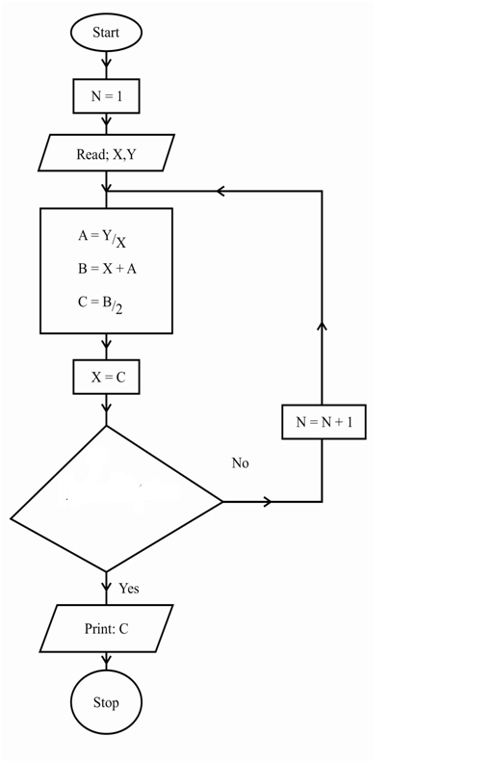
$C-X≤{10}^{-3}$?
Is
- Perform the dry run of the flow chart for $Y = 60$ and $X = 7$.
- State the purpose of the flow chart.
(07 marks)

END

